
Theory Assignment Report
Only for course Teacher
 |  | Needs Improvement | Developing | Sufficient | Above Average | Total Mark
Allocate mark & Percentage |  | 25% | 50% | 75% | 100% | 20
Clarity
Content Quality
Spelling & Grammar
Organization and Formatting
Total obtained mark
Comments

Semester Fall : 2026
Student Name: Abidul Islam Abid
Student ID: 26010126
Batch: 46th Section: A
Course Code: CSE 124 Course Name: Object Oriented Programming
Course Teacher Name: Debabarata Mallick
Designation: Lecturer
Submission Date : 29 /07/2026

1 ) Write a Java program to print 'Hello' on screen and your name on a separate line.
Hello
Alexandra Abramov

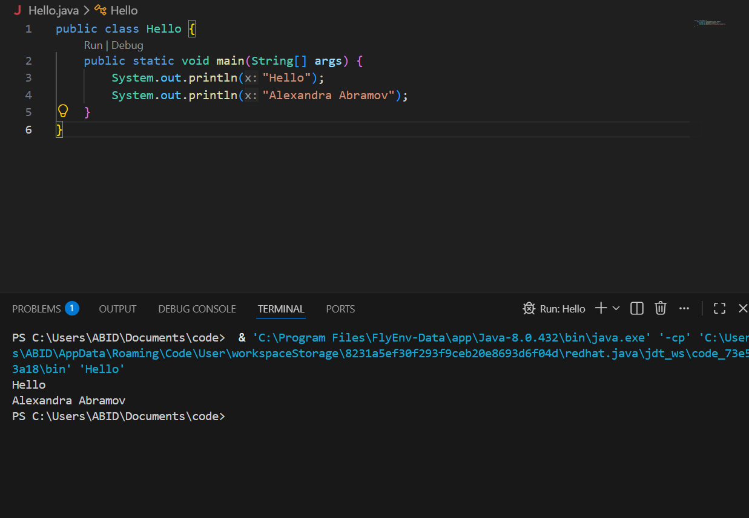

Comment : This program helped me understand the basic structure of a Java program and how to display text on the next line.

2) Write a Java program to print the sum of two numbers.
Test Data:
74 + 36

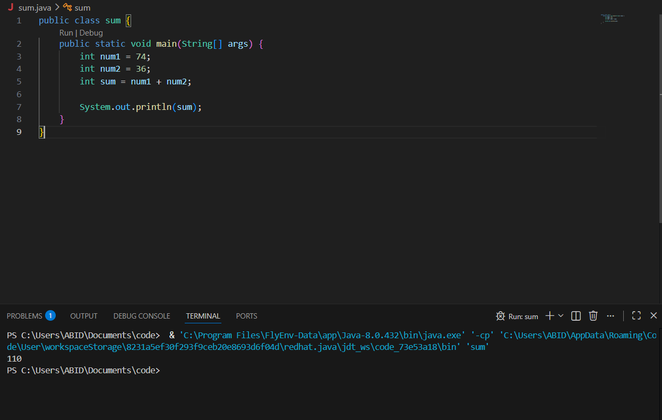

Comment : This program taught me how to declare variables, perform addition between two numbers, and store the result in another variable.

3 ) Write a Java program to divide two numbers and print them on the screen.
Test Data :
50/3

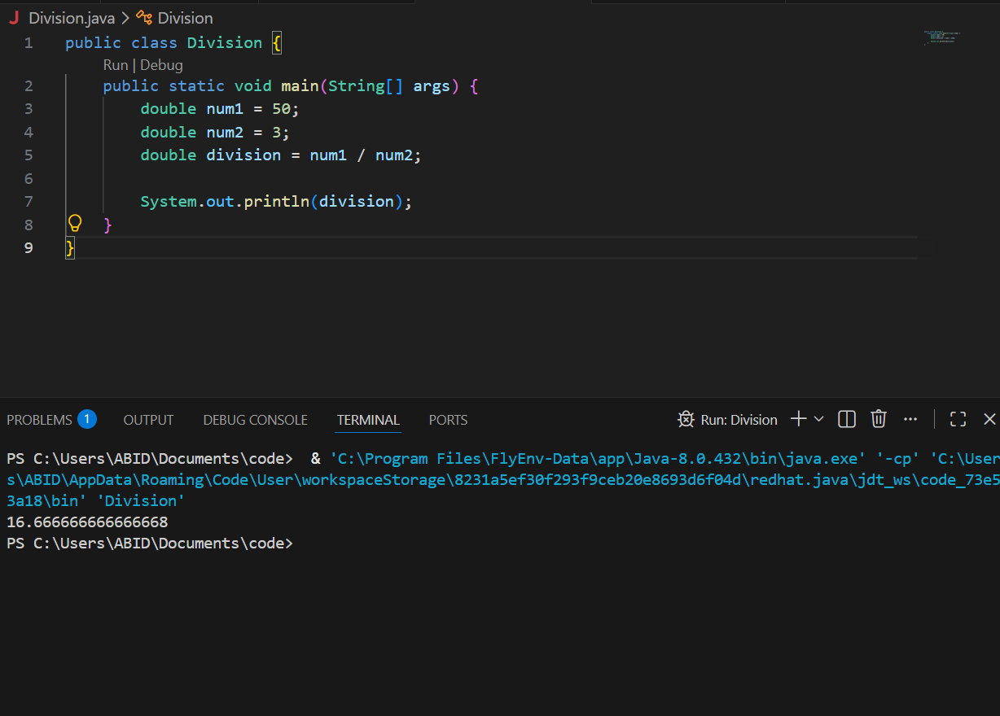

Comment : This program helped me learn the difference between integer and floating-point division by using the double data type.

4 ) Write a Java program to print the results of the following operations.
a. -5 + 8 * 6
b. (55+9) % 9
c. 20 + -3*5 / 8
d. 5 + 15 / 3 * 2 - 8 % 3

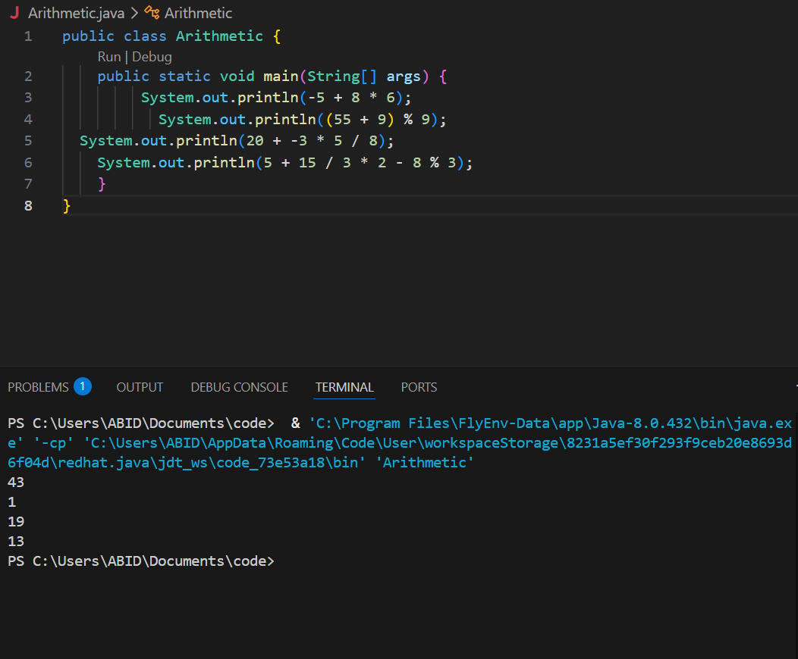

Comment : I Learned from this program how Java evaluates arithmetic expressions using operators (+, -, *, /, %) and follows operator precedence.

5 ) Write a Java program that takes two numbers as input and displays the product of two numbers.
Input first number: 25
Input second number: 5

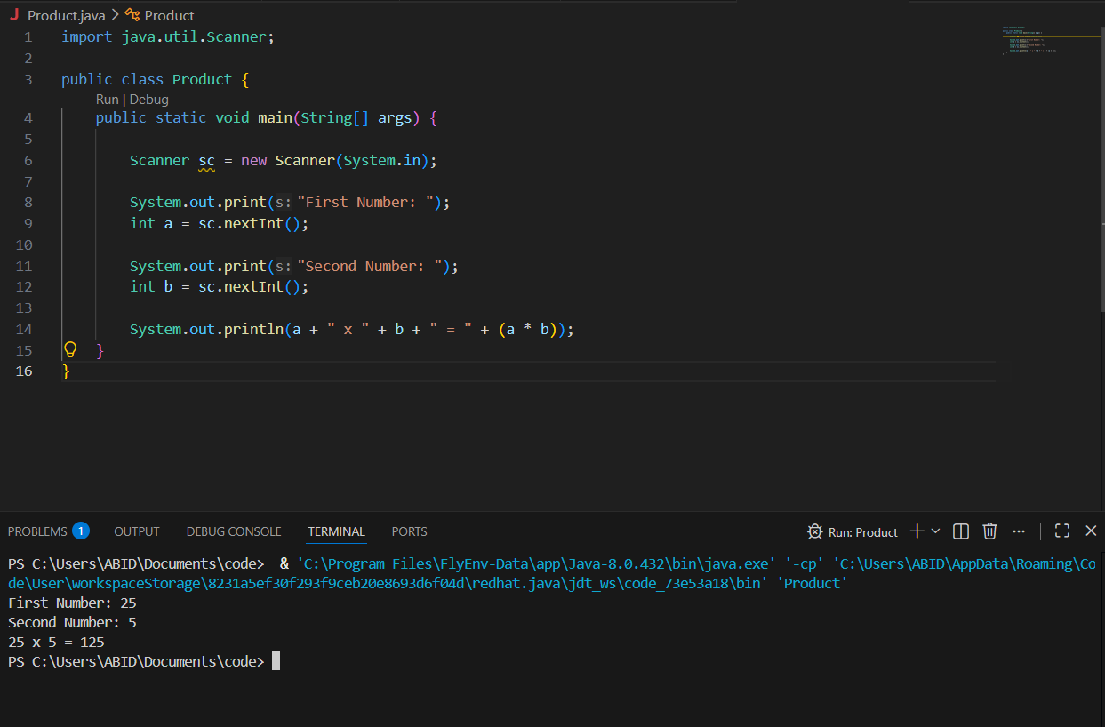

Comment : Learned how to take user input using the Scanner class, perform multiplication, and display the calculated result.

